Directorate General of Works
Central Public Works Department

No. 3/3/2003-(S&D)/ Dated: Nirman Bhawan May, ___ 2004

Office Memorandum

Sub: Preparation of statement containing brief activities of Ministry of Urban Development & Poverty Alleviation for the year 2003-04.

Ref: Ministry of UD&PA OM No. D-29013/1/2003–Coord., dated 27.01.2004

In pursuance of the above mentioned OM material for preparation of the document is sent herewith.

V.K. Sharma
Director (S&D)

To

Dy. Secretary (Coord.)
Min. of UD&PA
Nirman Bhawan

Copy for information to DS(W&UT), Ministry of UD&PA

Director(S&D)

CHAPTER 9

CENTRAL PUBLIC WORKS DEPARTMENT

The Central Public Works Department (CPWD), is the principal agency of the Government of India for creation and maintenance of all Central Government assets excluding those belonging to Railways, Defence, Communication, Atomic Energy, Airports (National and International) and All India Radio. CPWD was created in July 1854 when the then Governor General, Lord Dalhousie, decided to set up a central agency for execution of ‘Public Works’. The Ajmer Provincial Division was the first to be created and it executed many works including famine relief. However, CPWD was formally created in its present form in 1930.

CPWD has entered into 150th year of its existence in the year 2003-04.

The Central Public Works Department handles a wide range of projects like Housing and Office complexes, Hospitals, Workshops and Factories, Hostels and Hotels, Food Grain storage structures, Roads, National Highways, Bridges and Flyovers, Airports, Computer Centres, Environmental and other utility services. It also executes Border Fencing, Flood lighting and Road projects in difficult terrain and under hostile conditions along the Indo Pak and Indo-Bangladesh border. It is an organisation which can render the most comprehensive services in the field of planning, designing, construction and maintenance management, for all Civil Engineering projects with Total Quality Assurance.

Over the years the department has created structures with engineering excellence, which are still being used. It has to its credit construction of a number of prestigious buildings like Rashtrapati Bhawan, North Block, South Block, Parliament House, Vigyan Bhawan and many Multi storeyed office and residential Structures all over the country. It has also developed infrastructure for sports, education, agriculture etc. It is actively involved in providing facilities for the Central Para Military Forces. Department has also executed many overseas works such as construction of Embassies and Hospital Buildings in various countries and Roads & Bridges in Nepal. Presently it is executing works in Afghanistan for the Ministry of External Affairs.

Involvement of CPWD with a project starts from the stage of selection of site, carrying out geo-technical investigations, collection of field data, assisting the client in analyzing their requirements, preparation of architectural, structural, electrical, air conditioning and landscape designs and drawings, undertaking construction management including quality assurance and continuing its responsibility through post completion maintenance management etc.

The Department is moving forward in the field of construction by developing innovative techniques and adopting state-of–the Art technologies. A Technology Application and Development Cell (TAD Cell) has been established to identify and select environment friendly construction materials and technologies in close liaison and co-ordination with Research Organisations.

9-1
CPWD is playing a major role towards sustainable development of human settlement. It has also developed expertise in Rehabilitation of Structures and is imparting its expertise to rehabilitate structures in distress. A manual for Repair and Rehabilitation of Buildings has been recently brought out by the department.

CPWD has well documented Specifications & Standards and Schedules of Rates, which are updated from time to time, to keep pace with latest Technologies and market trends with a definite Quality Assurance Plan. These publications are followed by various construction organisations both in public as well as private sectors. Besides this, the department brings out a number of manuals for assisting in execution of projects. Guidelines for designing buildings for elderly and disabled people, Manual of rain water harvesting etc. published by CPWD have been found very useful by everybody.

The department also assists the Income Tax Department in implementation of Direct Tax Law so far as they relate to immovable properties. The Civil Construction Unit of the Ministry of Environment is manned by CPWD engineers. Similarly the Andaman and Nicobar Islands have also encadered a post of Chief Engineer with CPWD to help manage their PWD.

Establishment has Director General Works as its head. Jurisdiction of the department is divided into seven regular Regions. The Director General Works is assisted by Additional Director General (Works) for effective control of works and in administration matters. Its field units are located all over India to take up construction and maintenance works even in the remotest parts of the country. Through its countrywide network of planning and construction units, it is in a position to undertake the works of Public sector Undertakings and Autonomous bodies as Deposit works also.

The department has a decentralized system of working, which provides for better & easily accessible service as the units are placed close to work centers. Autonomy, in most areas, has been given to the Regional Units headed by ADGs. The jurisdiction of various regions is as below:

ADG (Strategy & Planning) (Headquarter – Delhi)
ADG(S&P) is in-charge of establishment and administrative functions of the department. There are two Chief Engineers (CEs) and two Directors looking after administrative functions relating to Vigilance, systems and personnel matters assisting the ADG. In addition ADG(S&P) is also incharge of the New Delhi Region. There are three zones under this region. Chief Architect (NDR) provides the architectural support to these zones.

ADG (Technology Development) (Headquarter – Delhi)
The ADG(TD) heads the Delhi Region also. There are two Civil zones and one electrical zone in the Region. In addition there are three CEs for looking after the Head Quarter functions relating to Design, Contract, Standards, Quality Control functions and Consultancy Services.

9-2
ADG (Northern Region) (Headquarter – Delhi)
ADG(NR) is responsible for the works under Northern Region. There are four CEs(Civil), one CE(E) and one Chief Architect in this Unit. Zones are located at New Delhi, Chandigarh, Lucknow and Jaipur for looking after the works in the States of UP, Punjab, Haryana, Himachal Pradesh, Rajasthan, U.T. of Chandigarh, Uttaranchal, J&K and in National Capital Region.

ADG (WR) (Headquarter – Mumbai)
ADG(WR) is responsible for works under Western Region. Jurisdiction of the region covers the states of Maharashtra, Madhya Pradesh, Chattisgarh, Goa, Gujarat, and Union Territory of Dadra and Nagar Haveli. There are three CEs (Civil), one CE(E) and one Chief Architect under this unit.

ADG (ER) (Headquarter - Kolkatta)
ADG(ER) is responsible for works under Eastern Region. Jurisdiction of the Region covers the states of West Bengal, Bihar, Jharkhand, Sikkim, Orissa and all the North Eastern States. There are three CEs(Civil), one CE(Electrical) and one Chief Architect in this Unit .

ADG (SR) (Headquarter – Chennai)
ADG(SR) is in-charge of works in Southern Region in the States of Tamil Nadu, Andhra Pradesh, Karnataka, Kerala and Union Territory of Pondichery, Andaman Nicobar and Lakshdeep Islands. There are three CEs(Civil) and one CE(Electrical) in this unit.

Engineer-in-Chief (PWD) (Headquarter – Delhi)
The public works of National Capital Territory of Delhi are handled by CPWD through four Zones in Delhi PWD under the Engineer-in-Chief, PWD. The E-in-C (PWD) reports to Govt. of NCT Delhi for day-to-day functions.

ADG (Border) (Headquarter- Delhi)
There is one post of Additional Director General for coordinating the activities of various organisations involved i.e. CPWD, Assam PWD and Border Roads Organisation in construction of Border Fencing, Roads and Lighting Systems along Indo-Bangladesh and Indo-Pak Borders. Five CPWD Zones, 3 civil and two electrical, are directly engaged in these works.

ADG (Architect)
The ADG (Arch.) exercises technical control on all the four Chief Architects. He is also advisor to Ministry of UD&PA on matters of Architectural Planning within the country and for Indian Embassies in other countries.

ADG (Training)
There is one post of ADG (Training), which looks after the training needs of the workers and officers in the department and carries out the important task of Human Resource Development. The department has a full fledged Training Institute located at Ghaziabad, apart from Regional Training Centres at Delhi, Mumbai, Chennai and Calcutta.

9-3
CPWD is an organization which has expertise in all facets of construction activity. The presence of highly qualified architects, civil engineers, electrical engineers and horticulturists ensures that the projects entrusted to CPWD by the clients get to be handled in a comprehensive manner. It renders consultancy in the field planning and design and also takes up supervision consultancy through its Consultancy Wing for PSUs, Autonomous bodies, Co-operative Societies and for projects abroad. It has so far provided consultancy services for many works in as many as 10 countries outside India.

SPECIALISED UNITS
To achieve excellence in its operation, CPWD has under mentioned specialised units.
- Central Design Organisation
- Training Institute
- Landscape Horticulture Unit
- Standards and Specifications
- Technology Application & Development Cell
- Consultancy Cell
- Techno-legal Cell
- Quality Assurance Wing
- Architectural Documentation Centre
- Central Laboratory

Central Design Organisation
Central Design Organisation (CDO), a specialised unit of CPWD, was formed in the year 1969. It has following four units each headed by a Superintending Engineer.
- Design Unit.
- Computer Centre (CC Unit)
- Repair & Rehabilitation Unit(RR Unit)
- Technology Application & Development unit

Since its inception, the activities of CDO have become manifold to meet the modern developments, particularly in the field of structural design, computerization, adoption of new materials and new construction techniques, materials testing, soil investigations, repairs and rehabilitation of structure in distress, development of soft ware etc. This unit is entrusted with the work of structural designs of major structures costing more than Rs.8 crores and /or buildings/structures of complex nature and promoting new techniques and materials in the field of building construction.

The Repairs and Rehabilitation Unit has been created to suggest corrective measures for the structures in distress. This unit has recently brought out a manual on repairs and rehabilitation of buildings which has been very received by practicing engineers.

The Computer Centre has been entrusted with development of software and implementation of computerisation in CPWD. The unit has developed a number of utility software for use by the department in the field of estimating, planning, designing, HR management etc.

9-4
Contracts, Standards and Quality Assurance Unit
This unit has four branches. Functioning of each branch is as under: -
(i) Contract and Manual Unit
This unit is responsible for registration and revalidation of contractors, updation of CPWD manual. This unit also issues Technical Circulars in respect of Contracts, Manuals and Delegation of Powers to various officers of CPWD. The revised and updated Manual Volume-II, used for regulating the works incorporating many important changes in work procedures has been recently brought out.

(ii) Quality Assurance Unit
This unit is responsible for conducting inspection of various construction and maintenance works, issue of Inspection reports for assurance of quality in the works. Regular inspections of major works are carried out by this unit.

(iii) Techno legal cell
This unit is responsible for dealing with the arbitration cases, Court cases, and approval of counter statement of facts in the Arbitration cases, other litigation matters and issue of circulars regarding all the above activities.

(iv) Standards & Specifications Unit
This unit is responsible for up dating the Specifications of works, issue of circulars from time to time, laying down specifications for new materials, approval of Cost Index, revision and up dating of schedule of rates etc. New CPWD schedule of rates has been brought out 2002. Specifications of RCC, in light of revised IS Code 2000, have been revised.

Training Institute

Training programmes for Group ‘A’ and Group ‘B’ officers are conducted in the main Training Institute of CPWD at Ghaziabad. The Institute has Regional Training centres located at Delhi, Calcutta, Mumbai and Chennai for group ‘B’ and ‘C’ employees of the department. The training of workers and Group ‘D’ employees is also undertaken at Regional Training Centers located in these metropolitan cities. Besides short term training programmes, the institute also conducts foundation training programmes for direct recruits group ‘A’ , (AEEs and Deputy Architects) officers, and Junior Engineers. Further, orientation programmes for SEs, EEs, AEs on promotion are also conducted.

Consultancy Services Organisation
CPWD provides consultancy services for various public sector organisations/autonomous bodies in planning, design and execution of major buildings projects, complex structures and specialised planning and services like air conditioning and electrical installations, project management etc. The departments Consultancy Services Organization (CSO) also provides consultancy services outside India for construction of Hospitals, Institutional Buildings, housing, Hostels and Office Buildings. During the year it has completed architectural planning for several projects like Handi Craft Bhawan at New Delhi, Qurters for Delhi Jal Board, Nuclear Science Centre, Delhi etc.

9-5
The CSO of CPWD has also taken up works on behalf of the MEA at Kabul. Repair and rehabilitation of Habiba School and of the Indira Gandhi Institute for Child Health, including completing the balance works, has been taken up during 2003-04. Some more works are in planning stage and are likely to be started next year.

Vigilance
The vigilance Unit of CPWD is headed by Chief Engineer (Vigilance), who is also the Chief Vigilance Officer of the Department. The activities of the Vigilance Unit include investigation of complaints, enquiries against erring officers and staff, issue of Vigilance Clearance Certificates for service matters, conducting surprise checks on stores and preventive vigilance by suggesting changes in the procedures.

ACHIEVEMENTS

WORKS
Equivalent work load of Rs.3538.35 crore has been achieved for the year 2003-2004. Refer Annexure-1.

1481 numbers of General Pool accommodations have been added by CPWD during 2003-04. Refer Annexure-2.

608.24sqm. of non residential General Pool accommodation has been completed during the year at Jaipur. Refer Annexure-3.

146 major works each costing more than Rs. 1 crore have been started during the year. Refer Annexure-4.

158 major works each costing more than Rs. 1 crore have been completed during the year. Refer Annexure-5.

70 major works costing more than Rs. 1 crore have been sanctioned during the year. Refer Annexure-6.

Achievements of the various specialized units of CPWD are given in Annexures 7 to 11.

Important events/foundation stone laying ceremonies/inauguration:
(i) The Hon’ble Prime Minister inaugurated Shiksha Sadan, a building built by
CPWD for Central Board Secondary Education at Rouse Avenue in New Delhi on July 29, 2003.

9-6
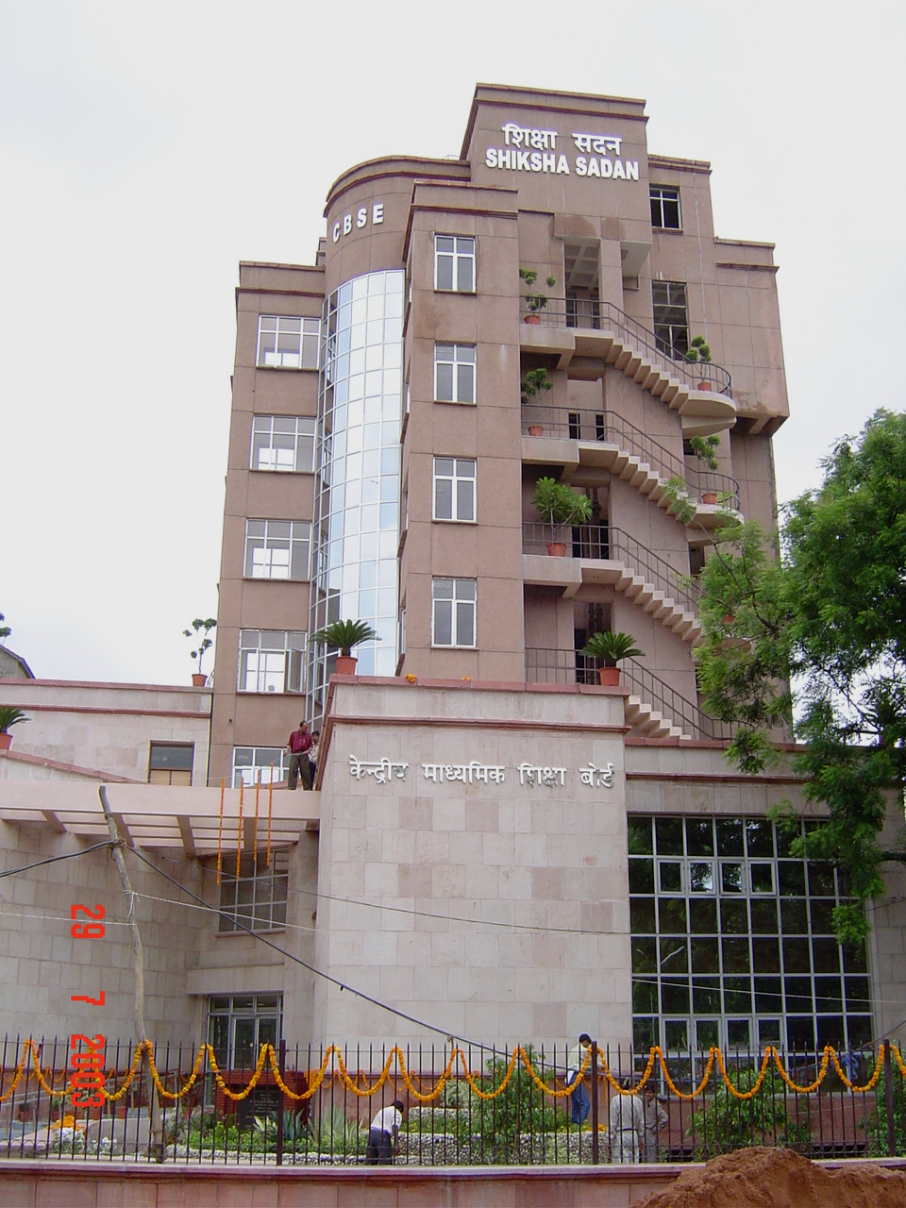
(ii) The President of India dedicated to the nation the Rajiv Gandhi Memorial at Sriperumbudar on October 10, 2003.
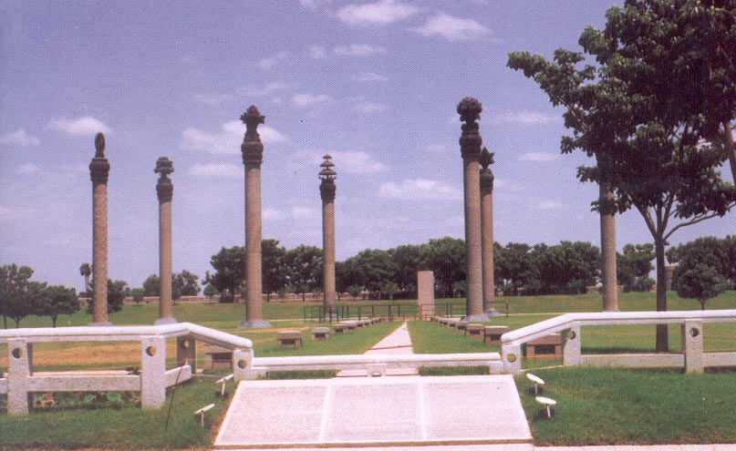

9-7
(iii) As part of its sesquicentennial celebrations the Central Public Works Department Organised a seminar in Vigyan Bhawan, New Delhi to deliberate upon the issue of its role in national development. Hon'ble Dy. Prime Minister Shri L.K. Advani was the Chief Guest and the function was presided over by Hon'ble Minister of State for Urban Development and Poverty Alleviation (Independent Charge) Shri Bandaru Dattatreya. The key note address was delivered by Shri Harish Chandra, former DGW, CPWD and former Member UPSC.
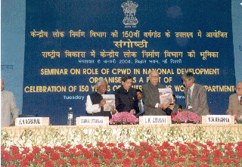
A detailed list of important events and activities of the department for the year 2003-04 is given in Annexure-12.

Activities in other important areas

Border Roads, Fencing & Flood Lighting Works
The Central Public Works Department is executing the work of Border fencing, flood lighting and construction of Roads along the international borders of the country both in the West and the East. In all 1505 Km of fencing, 232 Km of Road and 1483 Km of flood lighting along Punjab & Rajasthan Border has been completed by CPWD.

Along the Gujarat border 123 Km of road including link road has been completed and 132 Km is in progress. 16 Km of fencing and 52 Km of flood lighting and 14 Border out posts have been completed in this year.

1565 Km of road, having 14130m of bridges and 649 Km of fencing has been completed along Indo Bangla Border. 12 km road of road and 105 Km fencing has been completed in this year along this sector.

The maintenance of the infrastructure created along the border in the form of roads, bridges, flood lighting etc. has also been entrusted to CPWD. Special units have been opened in Rajasthan and North East to look after the works. 2482 Km of road along the full IBB is being maintained by CPWD.
9-8
Details of achievements are given in Annexure-13.

Construction of residential accommodation for Ministry of Defence
The Ministry of Defence has embarked on a project to provide residential accommodation for the armed forces. CPWD has been entrusted the work of constructing these at 12 locations in the states of Rajasthan, Punjab and J&K. Detailed project reports for 10 stations amounting to Rs. 1031.77 crore have been sent. Formal sanction is yet to be issued by the MOD.

Citizen Charter
To reflect the commitment of CPWD in the matter of construction and maintenance of Residential and Non-Residential buildings and other service activities following steps have been taken:

i) Citizen Charter has been formulated and adopted in CPWD.
ii) The Charter adopted has been put on the CPWD website www.cpwd.nic.in.

Computerisation
Computerisation has been introduced in areas like preparation of Architectural Designs, Structural Design & Detailing, Project Planning & Scheduling, Monitoring, Preparation of Schedule of Rates, Tender Justification, Pay Rolls, Personnel Management, Inventory control, Accounting and Budgeting, maintenance management etc.

A fully computerized complaint receiving and monitoring system has been put in use by CPWD in Delhi. The service can be accessed at http://cpwdsewa.nic.in .

All the regions have developed their own websites and have posted relevant details. These web sites can be seen at www.cpwdsr.tn.nic.in; http://cpwdnr.nic.in; http://cpwdwr.nic.in and http://cpwder.nic.in .

Activities of CPWD in North East.
CPWD has been executing number of infrastructural works in the North East. The head quarters of the CPWD in this area is located in Shillong with divisions located at Guwahati, Shillong, Imphal, Tejpur, Silchar & Agartala.

The works done by the Department cover such diverse sectors such as Education, Health, Sports, Tribal Welfare, Inland Waterway Transport, construction of Airport Terminals etc. It also has a major role in executing works for the various Central Police Organisations such as CRPF, BSF, Assam Rifles, SSB, ARC, SIB & SB that ensure maintenance of law and order in the region. Works for Ministry of Labour, Ministry of Health & Family Welfare, Central Water Commission, Survey of India, Ministry of Environment & Forests, ICAR, KVIC, Sports Authority of India and Central Ground Water Board etc. are being executed by the CPWD in NE region.

9-9
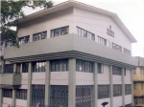  Ayakar Bhawan Shillong | 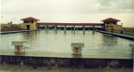  Sports Complex Agartala: Elevated swimming pool and stadium
 | 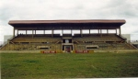

Some of the important works being handled in this region are:
(i) Construction of Low Level Jetty at Pandu, Guwahati, Assam
The work of construction of Low Level Jetty at Pandu, Guwahati on the mighty river Brahmaputra, for Inland Water Ways Authority, costing Rs.30 Crore has been started and is in progress. The project is targeted for completion by the end of 2005. The Inland Waterways Authority have proposed to get another High Level Jetty also constructed through CPWD at a nearby location and the pre-construction activities for the same have also been taken up.

(ii) Residential & Non-Residential Buildings for 5 Assam Rifles at Charduar, Assam
Construction of around 225 Residential Quarters of different categories, Barracks and other Non- Residential facilities for Assam Rifles Battalion at Charduar in Assam has been taken up by CPWD. The project estimate is Rs.40.66 Crores. It is targeted for completion in 2005.

(iii) Construction of Institute of Hotel Management, Guwahati, Assam
Construction Work of Institute of Hotel Management at Guwahati for Rs.12.80 crores has been taken up in financial Year 2003-04 and the project is targeted for completion in the year 2005.

(iv) Construction of Jawahar Navodya Vidyalyas
In North Eastern Region, C.P.W.D. is constructing a large number of Jawahar Novodaya Vidyalayas. Work is in progress in 28 Districts (Assam : 11, Arunachal Pradesh : 7, Meghalaya : 4, Manipur : 4 Nagaland : 1 and Mizoram : 1). In each JNV, School Building, Dormitories for Girls & Boys, Kitchen & Dining & Staff Quarters along with Boundary Wall and other development works are carried out.

In spite of the inclement weather conditions and difficulties posed by the remoteness of various sites among other things, the North eastern Zone of CPWD has been meeting the challenges and making steady progress since its inception.

9-10
Involvement of CPWD with the Ministry of Tourism

CPWD has taken up in a big way the works related to the Ministry of Art Culture and Tourism. Many works on other heritage sites such as Kurukshetra, Red Fort in Delhi etc. are also being carried out by CPWD. Special mention was made about the re-development work done by the CPWD around the Red Fort by the Hon. PM in his Independence Day speech.

Tourism related works in the states of Assam, Bihar, Delhi, Rajasthan, Jharkhand, Gujarat, J&K, West Bengal, Karnatka, Kerala, Madhya Pradesh, Rajasthan, Tamilnadu, UP, Uttaranchal, Maharashtra etc. are being done by CPWD.

Total 189 works are being executed by the department. Details are given at Annexure14.

9-11

